Year 10 student – GSCE Design and Technology NEA.
The Non-exam assessment (NEA) contributes towards 50% of the students’ overall mark. The NEA project in its entirety should take between 30-35 hours to complete and consist of a working prototype and a concise portfolio of approximately 20 pages of A3 paper, equivalent A4 paper or the digital equivalent.
Students' work consists of an investigation into a contextual challenge, defining the needs and wants of the user and include relevant research to produce a design brief and specification. Students generate design ideas with flair and creativity and develop these to create a final design solution (including modelling). A manufacturing specification is produced to conclude the design findings, leading into the realisation of a final prototype that is fit for purpose. They also complete a final evaluation.
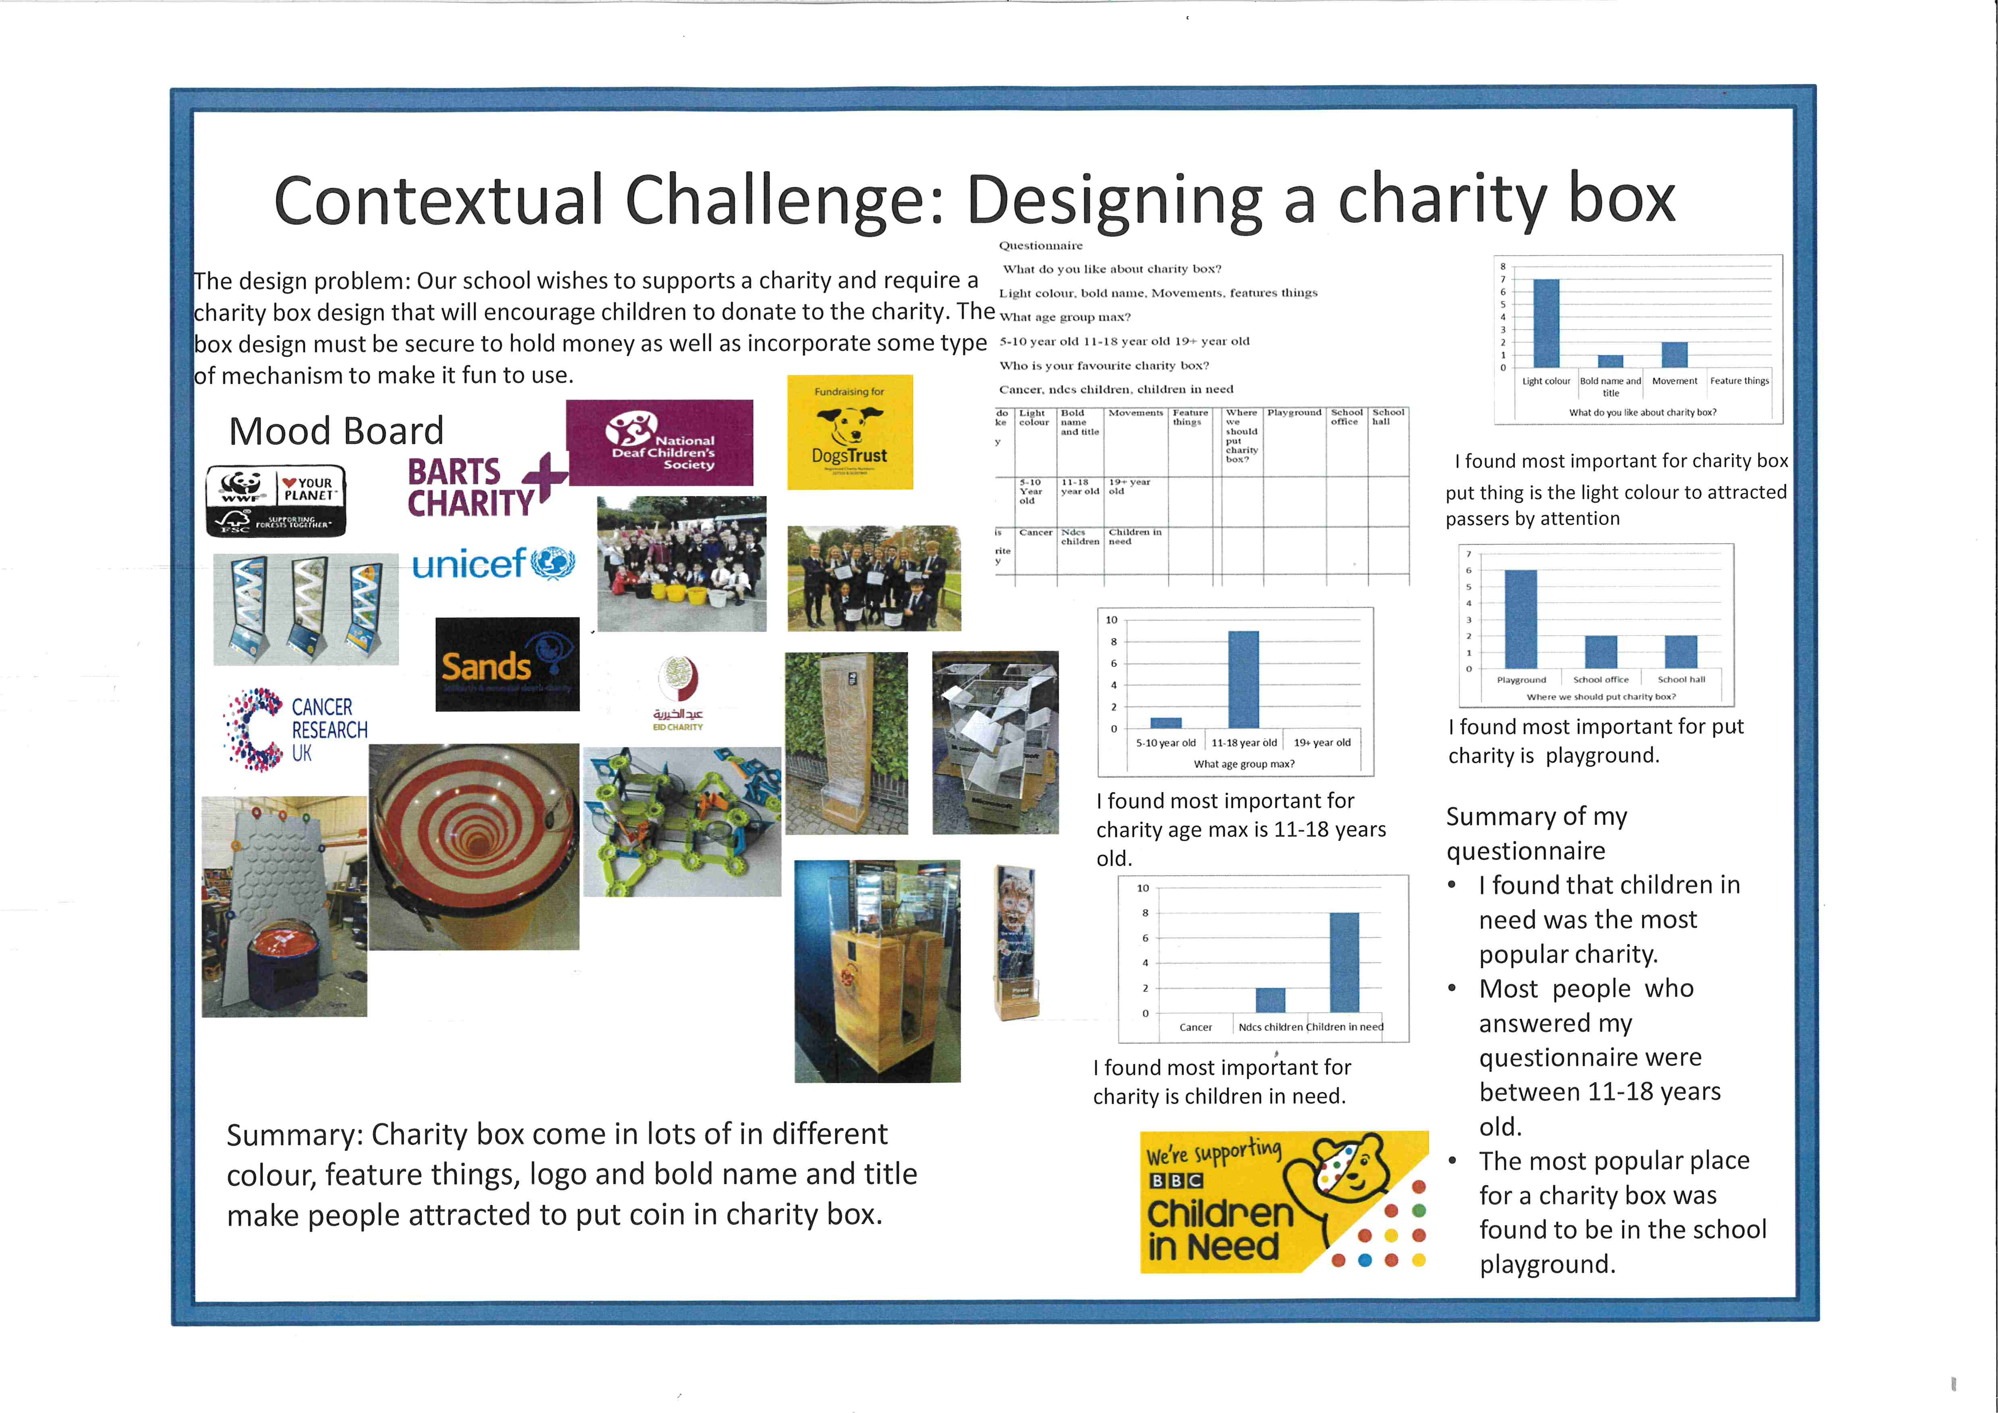
Students investigate, analyse and evaluate throughout the portfolio and evidence all decisions made.

