|  |
| --- |
| Year 10 student answering a GCSE Chemistry exam question independently. |
|  |

GCSE Science work - Year 10 Student

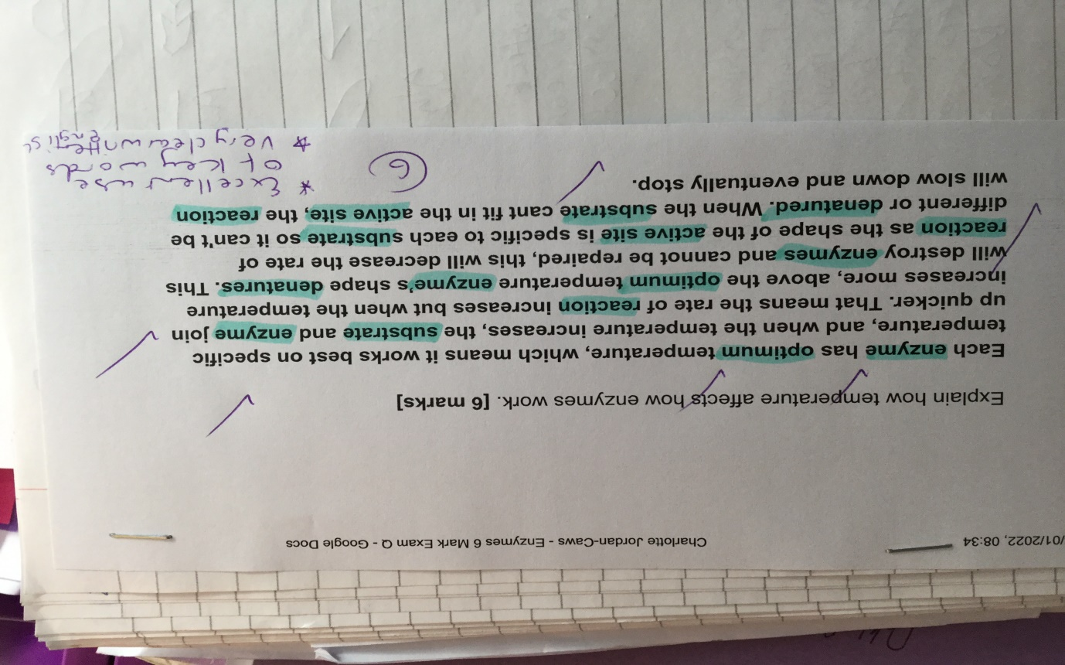

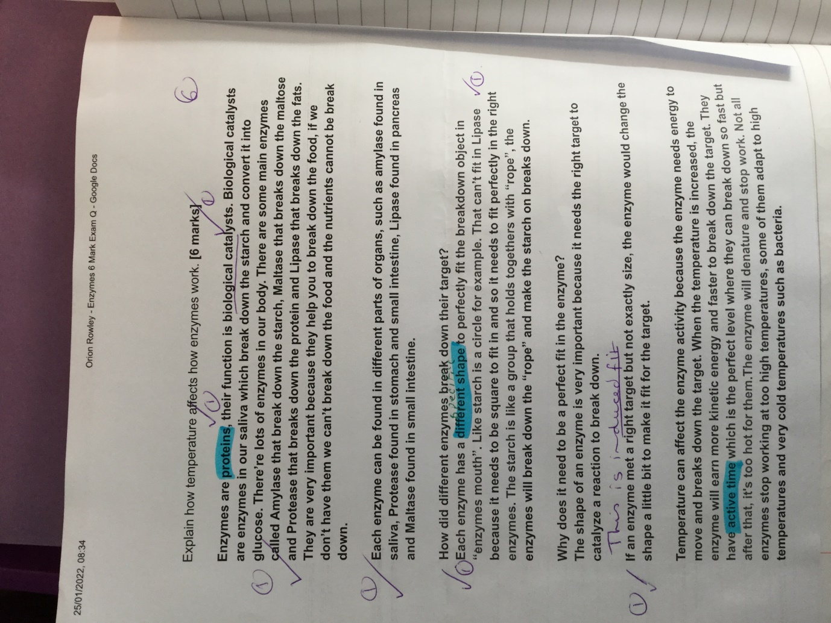

Entry Level Certificate Science Year 10 student