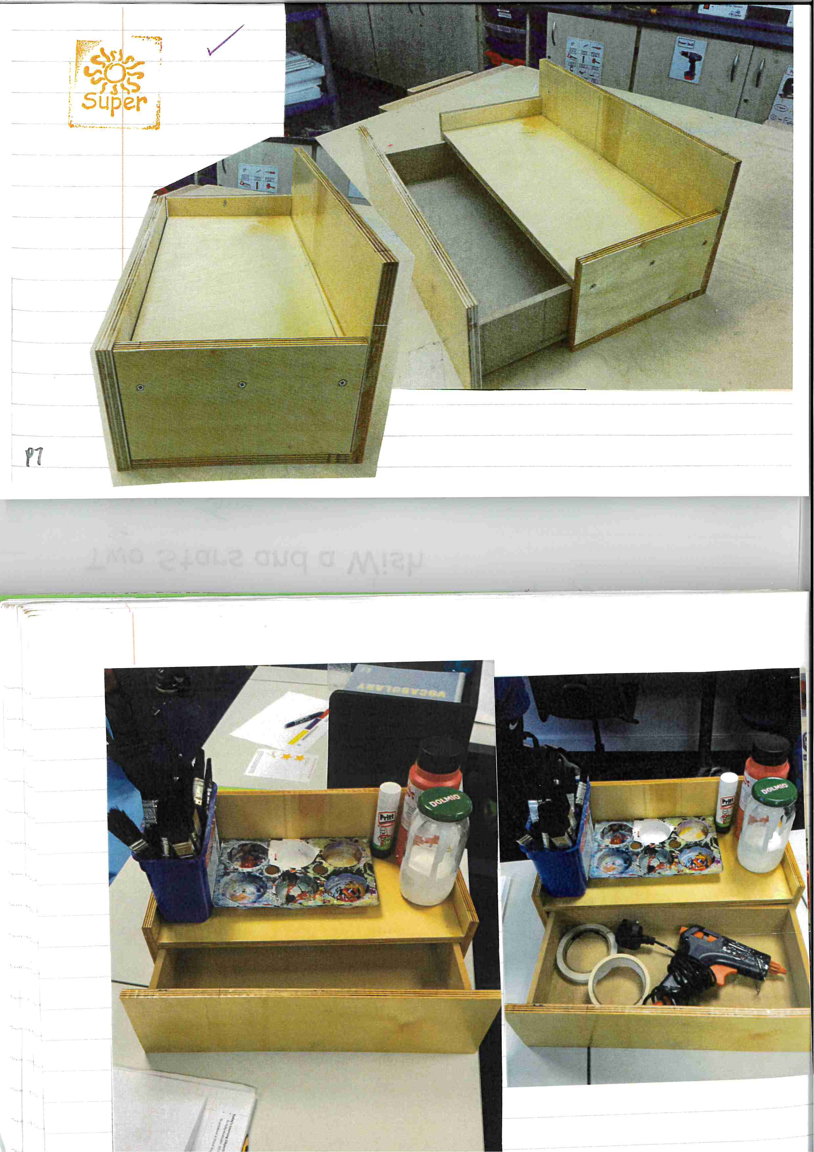
Year 10 student - product using timber. (desk storage)

