Year 10 – Pair work discussing possible risks in different situations (Managing Risks)
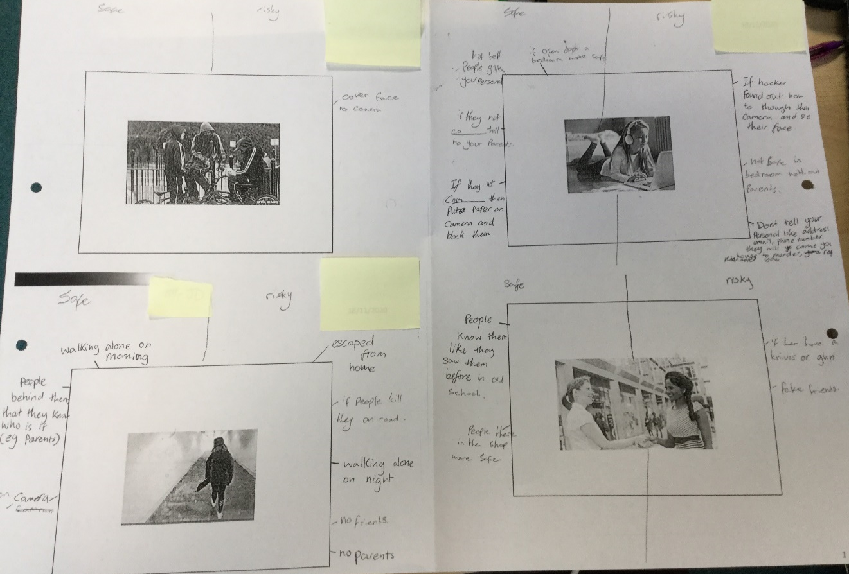

Year 10 – Understanding the difference between a democracy and a dictatorship
