GCSE Science Year 11 student

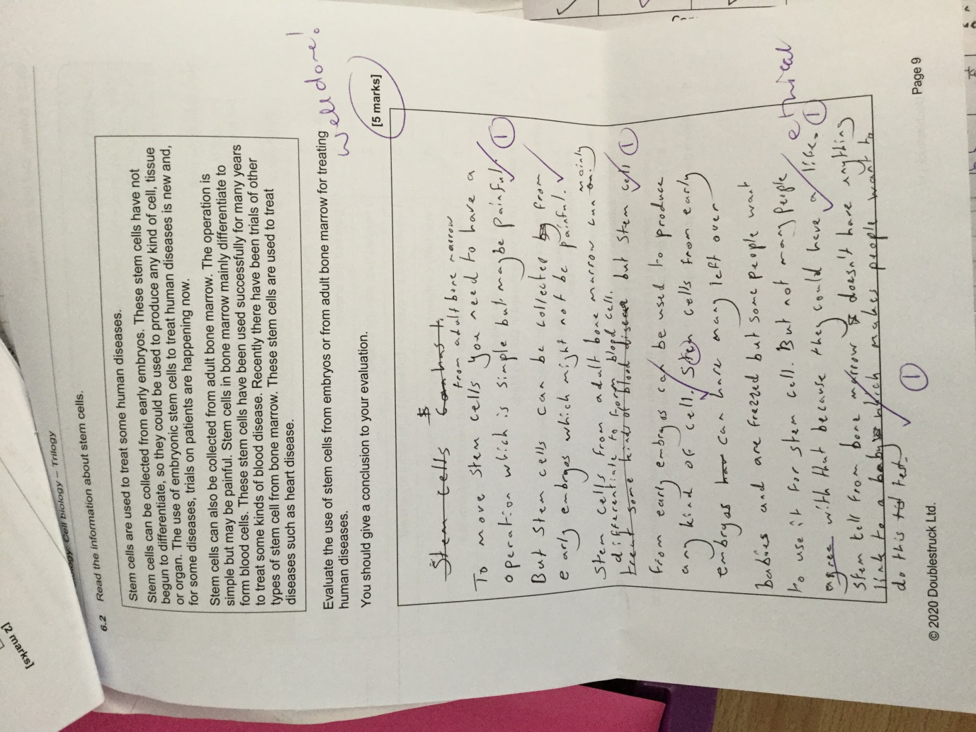

GCSE Science student
Higher tier exam practice paper
1st draft answering an exam question independently

