A year 7 student researched the causes of the Black Death and creating a newspaper article about it.

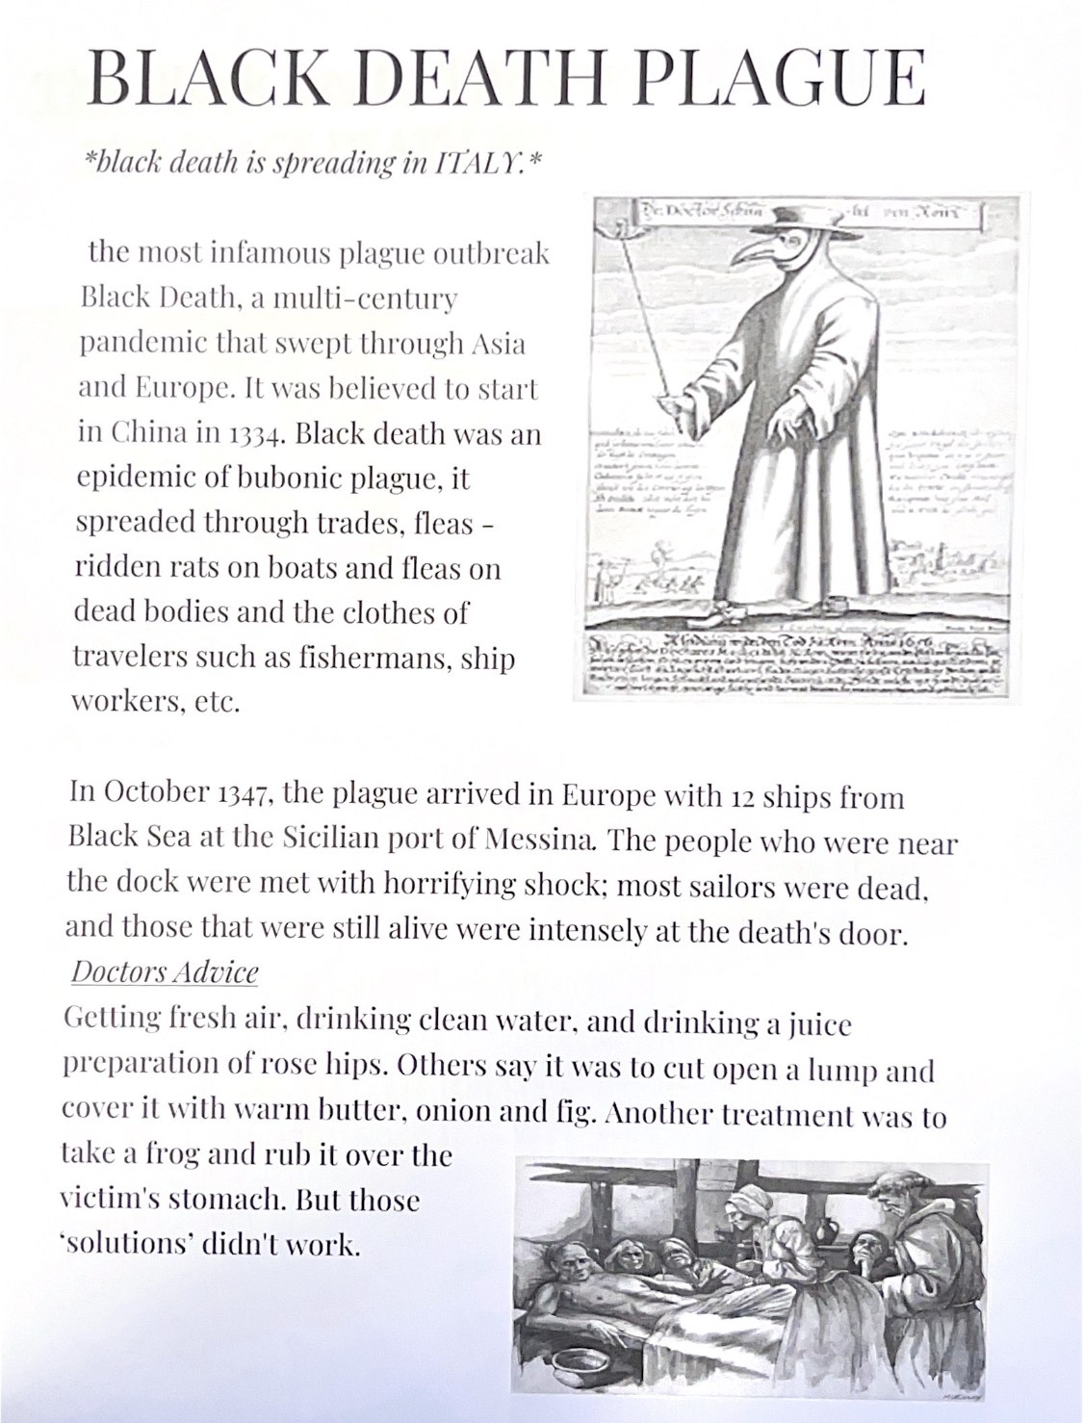

Year 7 group researched the family tree of Henry VII and how it linked to the War of the Roses.

