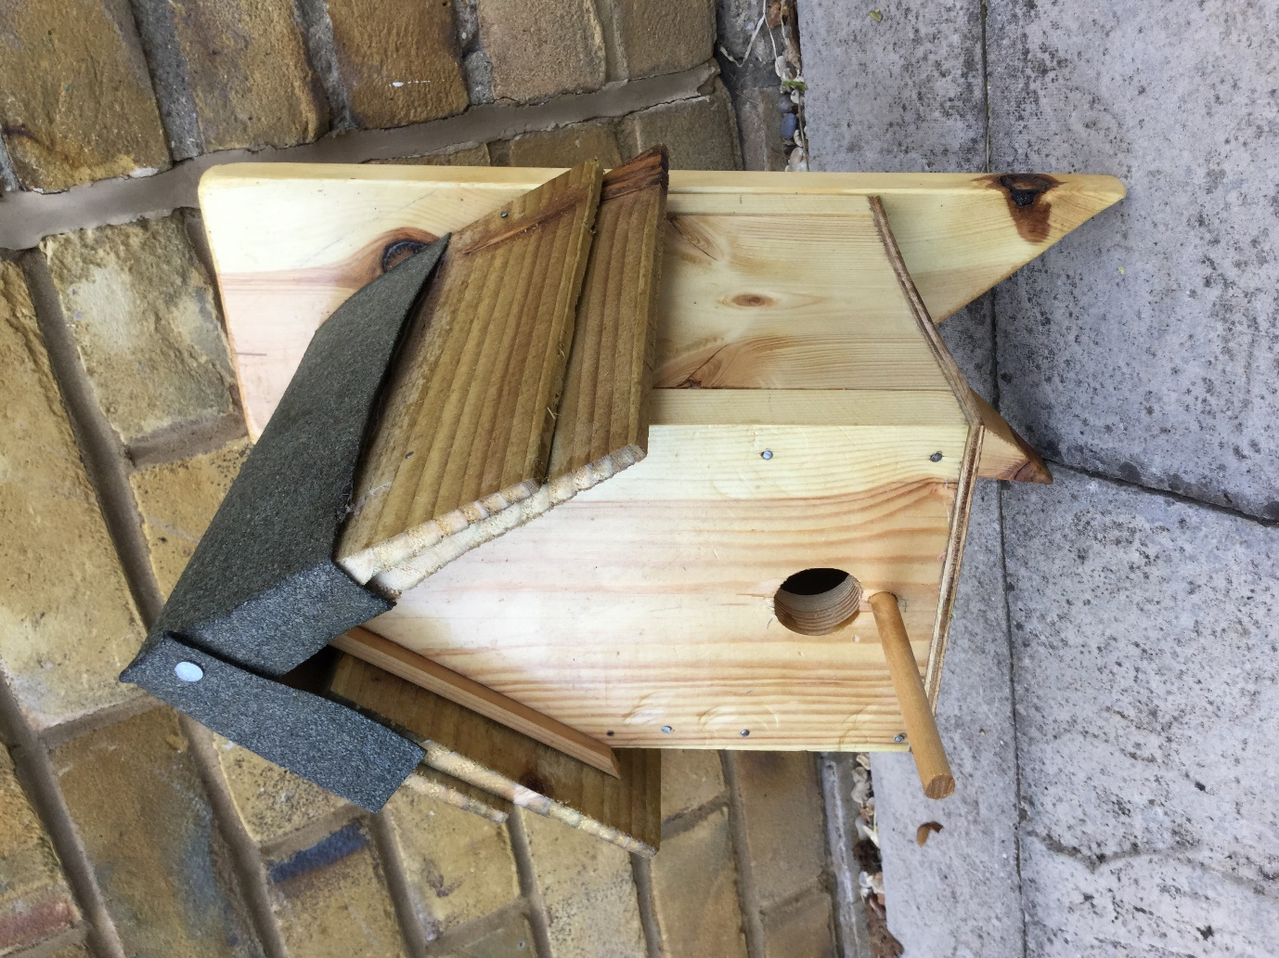
Year 7 student – product using timber (bird house).

