Fantastic example of a Year 7 student using HCF (Highest Common Factor) to factorise expressions!
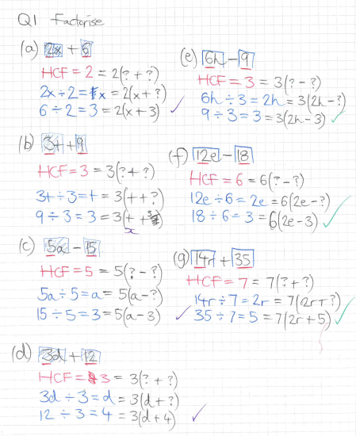
This student came up with his own unique way of factorising expressions

