Example of Year 7 maths work on angles
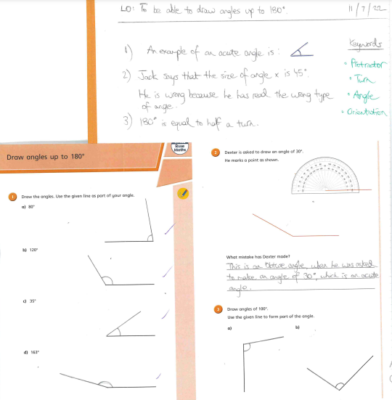
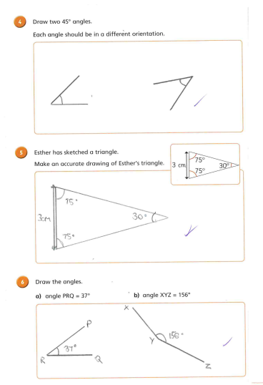
This student had to measure and draw angles accurately using a protractor as well as solve and provide reasoning for angle problems.

