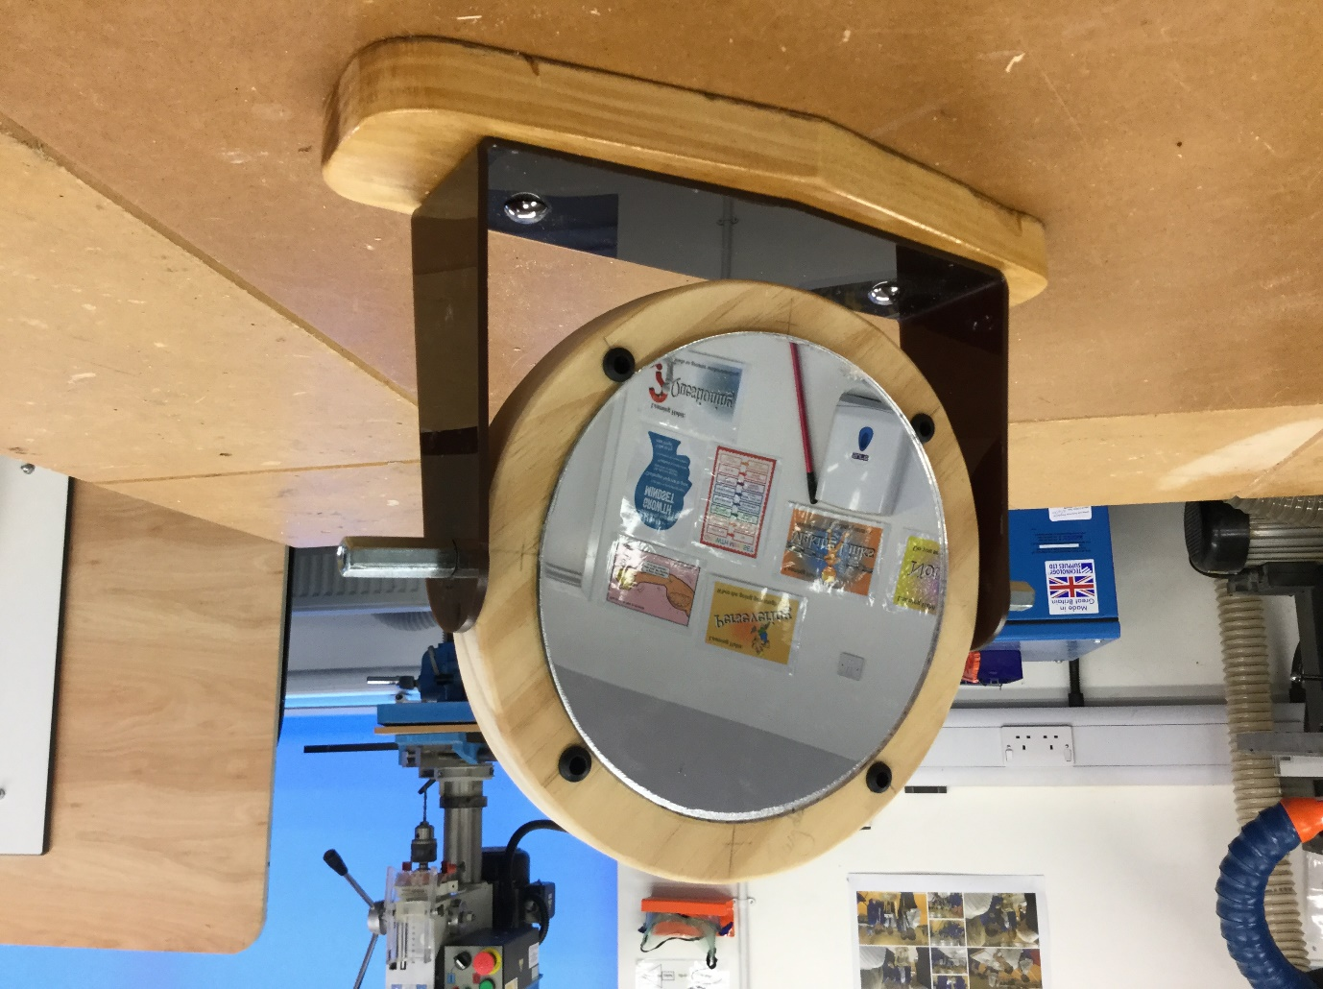
Year 8 student – product using timber and plastic material.

