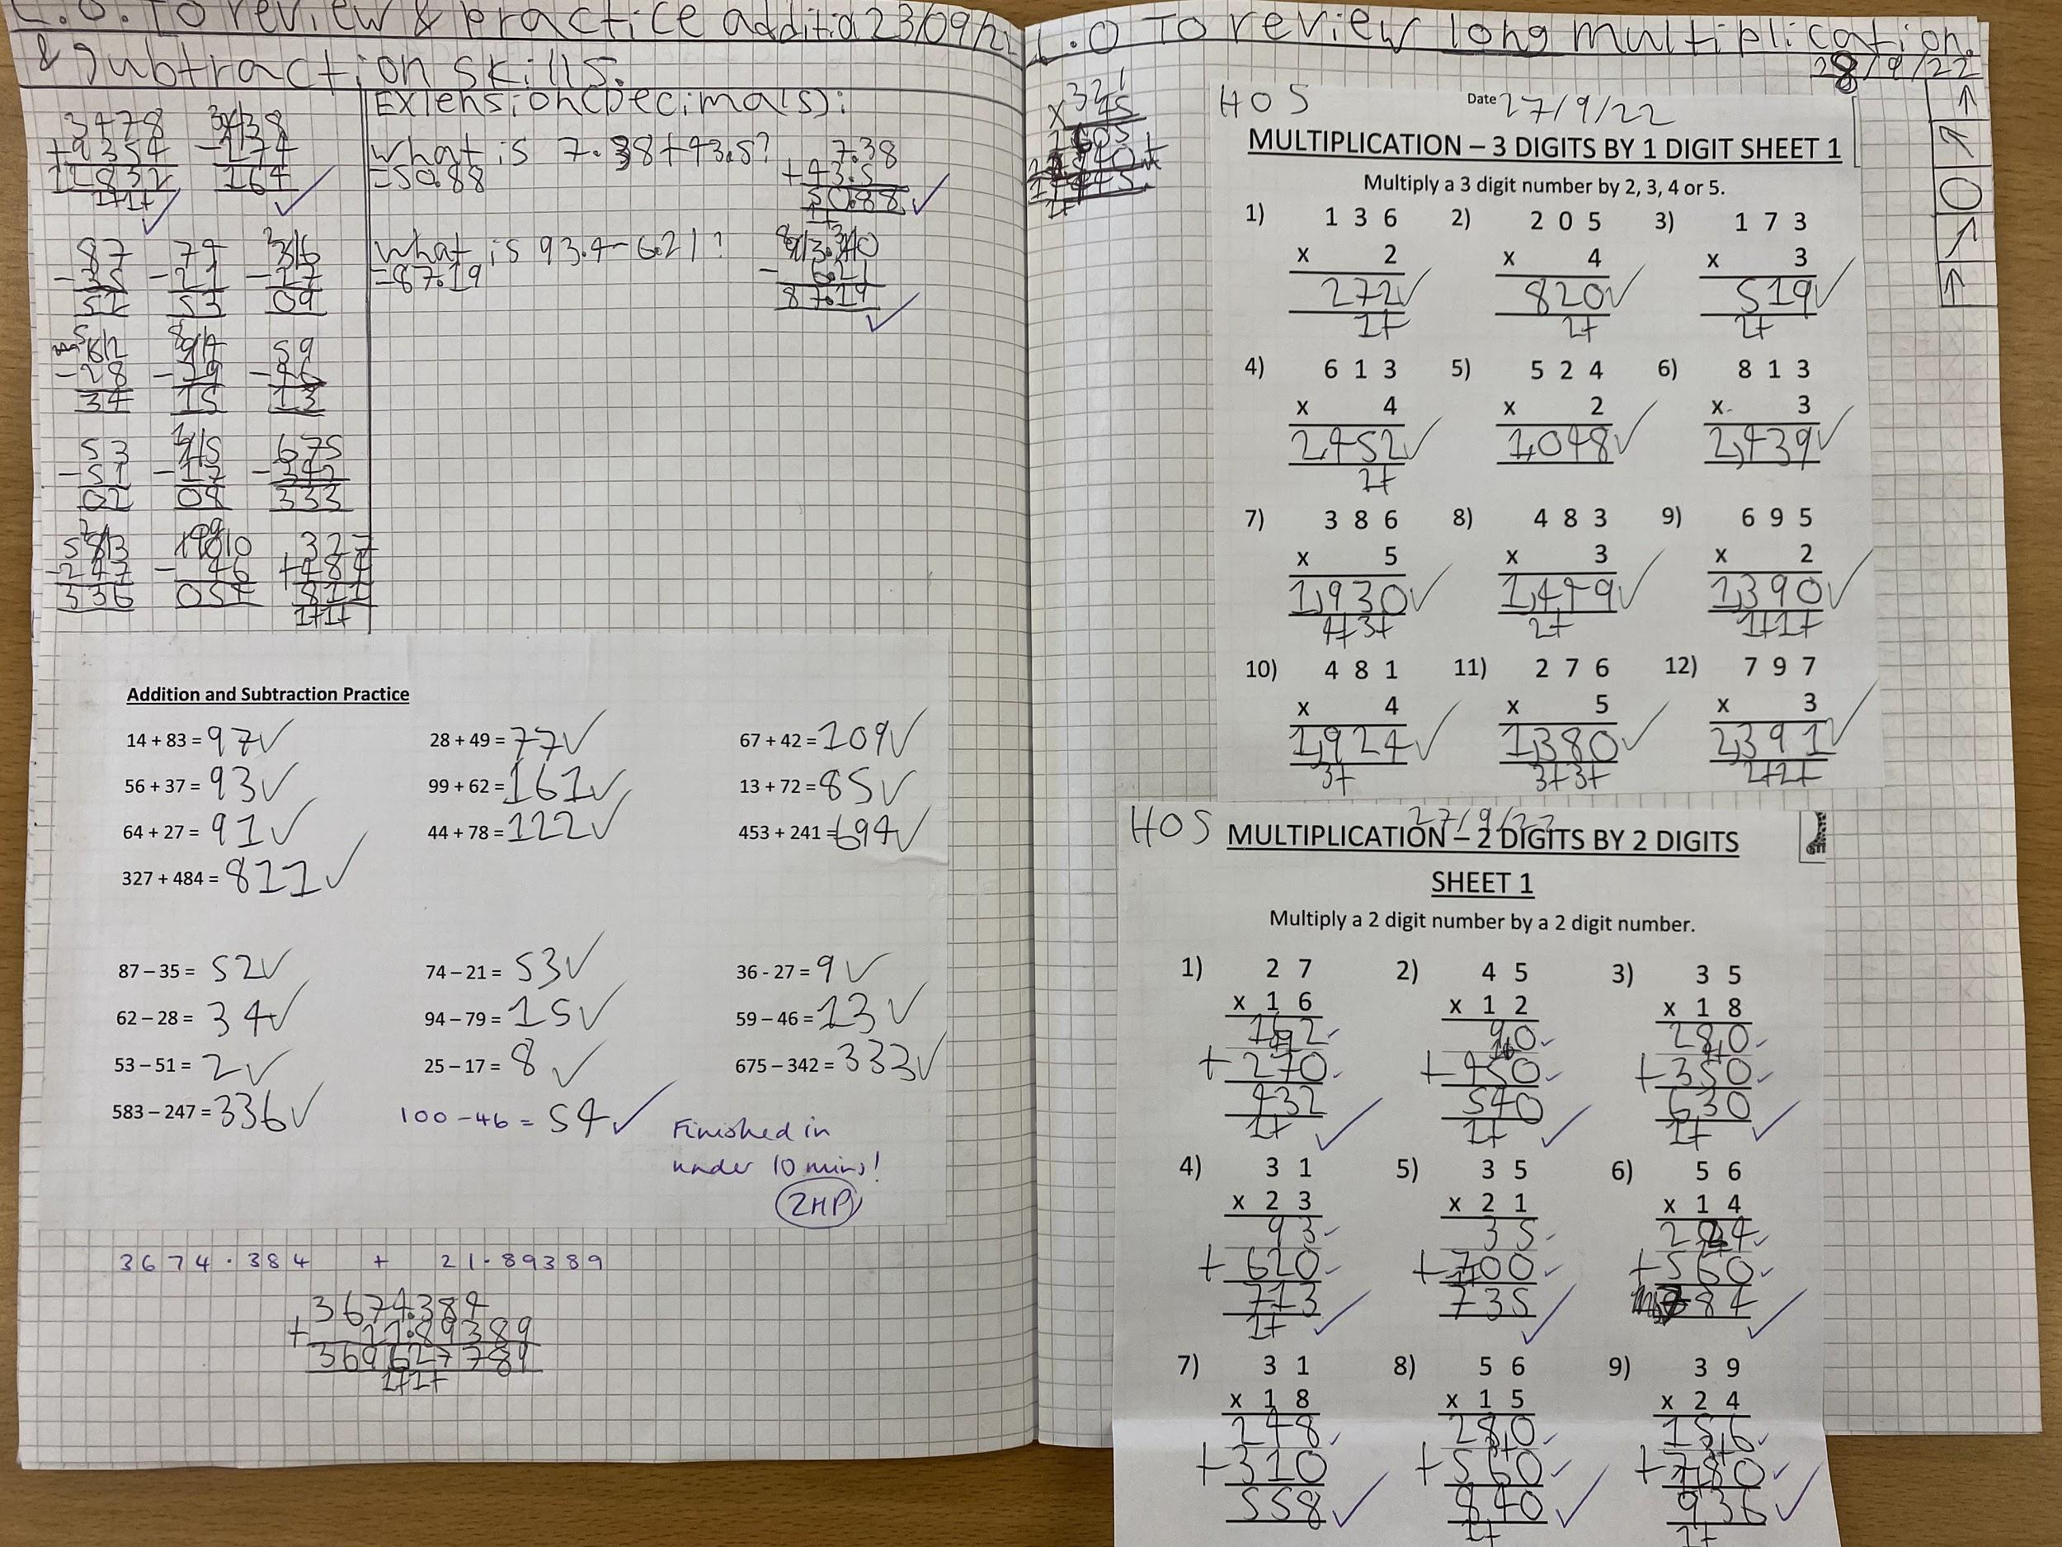

Year 9 Entry Level student practising her number skills.

