Calculations to find the HCF and LCM using Venn diagrams.
Year 9 student.
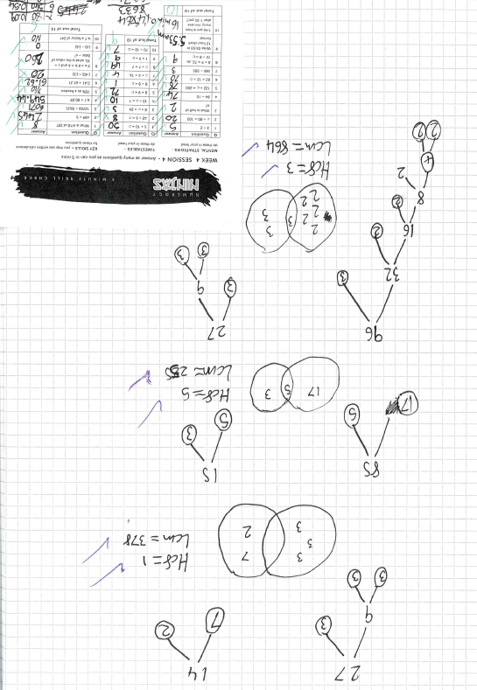
Students practise key skills regularly, using Numeracy Ninjas.
