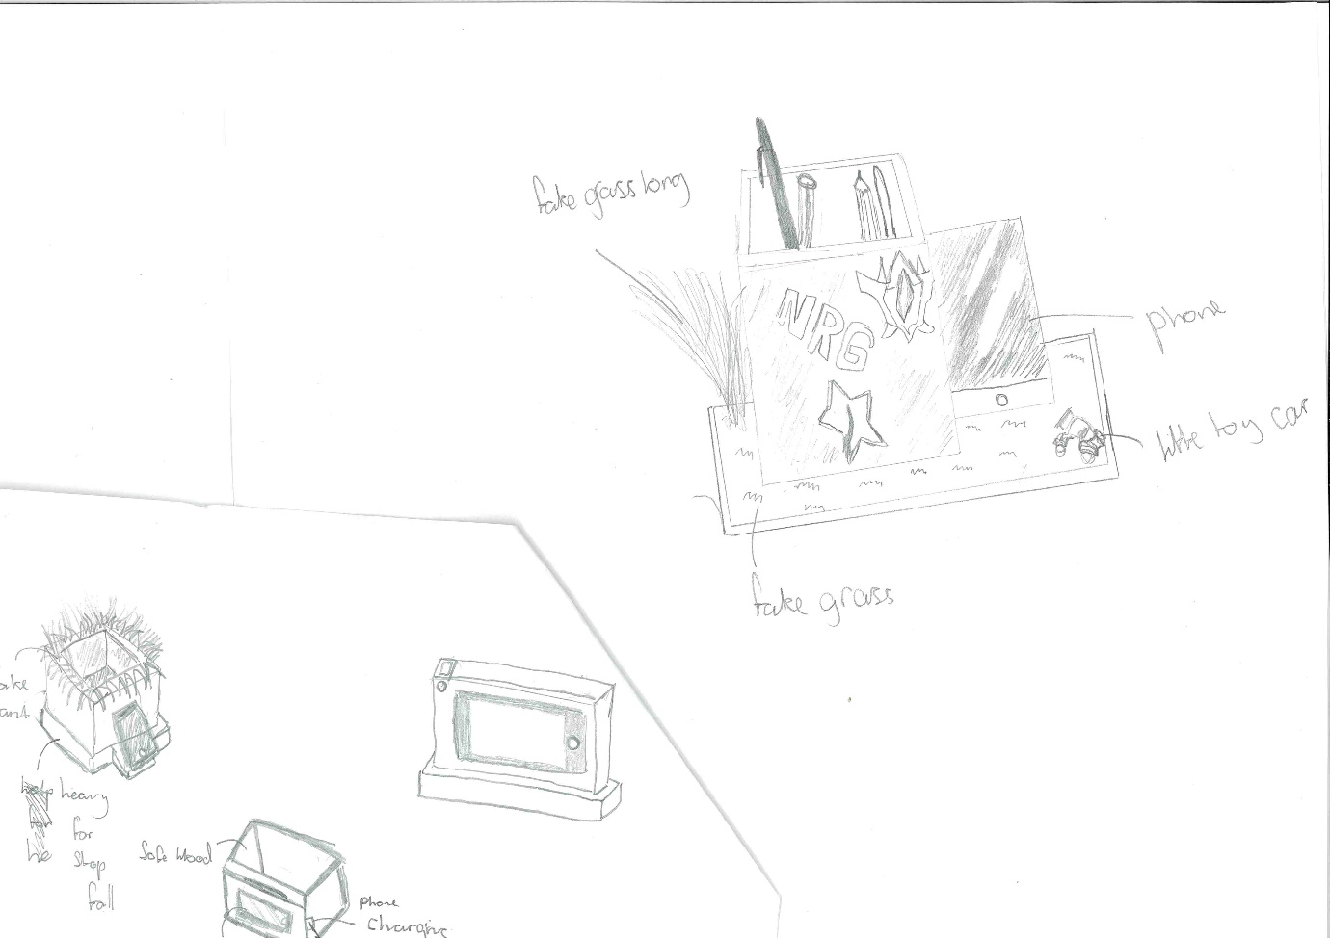
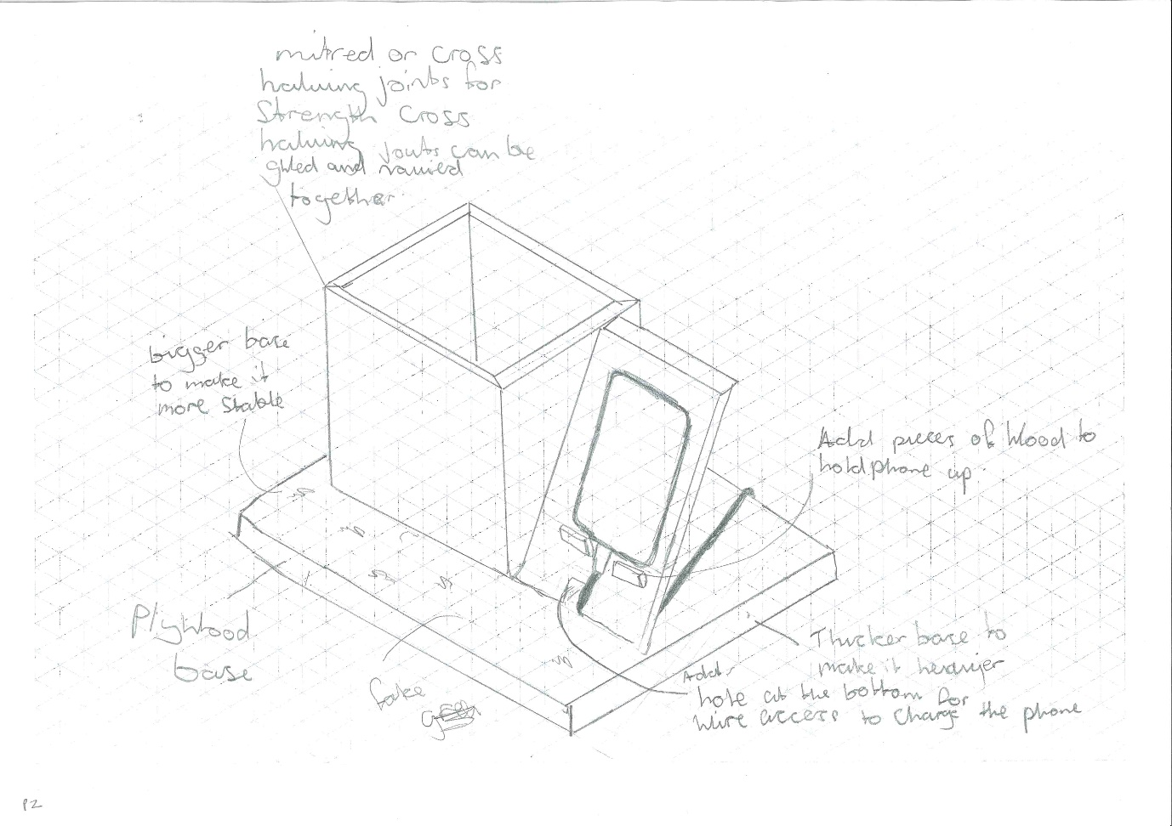
This shows a Year 9 student working on the desk tidy storage unit project
– it shows the process of designing, making a prototype, amending design and making the final product.

