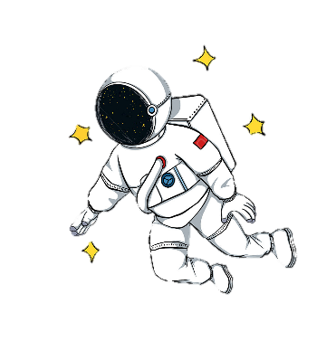  Year 6  Astronaut Class |  | 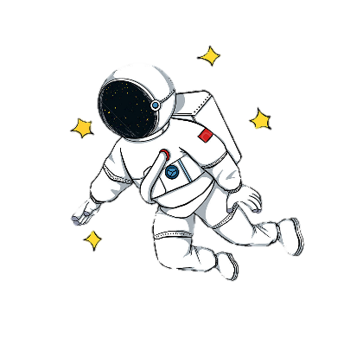  Topic Cycle year 2023-24
Subject |  | Autumn |  | Spring |  | Summer
Topic Title |  | WW2 |  | Disasters |  | Ancient Greece
T  O  P  I  C | History | WW2 Hi2/2.2 Extended chronological study |  | Disasters – Disasters in history. |  | Ancient Greece Hi2/2.4
 | Geography | Local area study Ge2/1.1b name and locate counties and cities of the UK human and physical characteristics, key features (including hills, mountains, coasts and rivers), and land-use patterns; and understand how some of these aspects have changed over time Ge2/1.4c use fieldwork to observe, measure, record and present the human and physical features in the local area using a range of methods, including sketch maps, plans and graphs, and digital technologies. |  | Ge2/1.3a describe and understand key aspects of physical geography, including: climate zones, biomes and vegetation belts, rivers, mountains and the water cycle Ge2/1.3b describe and understand key aspects of human geography, including: types of settlement and land use, economic activity including trade links, and the distribution of natural resources including energy, food, minerals and water |  | Ge2/1.1a locate the world’s countries, using maps
 | Art and Design | Andy Warhol painting - Drawing Sketching and drawing skills e.g. WW2 planes |  | Making a collage of the cross section of the volcano and the earth using different textured materials. |  | Sculpture Pottery - vase
 | DT | Seasonal Cooking DT2 2.1 (inc rationing recipes)  Wooden propellers- battle of Britain. |  | DT2 1.1.-1.4 Making mini greenhouses for lettuces – sow Feb indoors  Making volcanoes. |  | DT2/1.4 Moving Mythical Creatures
Science |  | Light | Electricity | Living things and their habitat | Animals including humans | Evolution | Experiments
Computing |  | Online safety  Networks | Coding | Spreadsheets | Quizzing | Blogging | Binary
RE  Christianity and  Judaism |  | Rules for living | Christmas Hanukkah – Light as a symbol | Celebrations linked to key figures e.g. Purim- Esther | Passover – Moses | Creation stories | Leaders – Rabbis/ Vicars
PSHCE |  | Deaf Studies | How can I deal with change, loss and bereavement? | How can the media influence people? | How can we choose the jobs would we like to do in the future | How can I help in an accident or emergency? | How do I keep myself safe in relationships?
PE |  | Invasion Games Tag Rugby=- | Swimming | Gymnastics | Net and Wall Games Badminton/Table tennis | Athletics | Striking and Fielding* - Cricket
WOW! |  | Lincolnsfield  De Havilland |  | Kidszania  Natural History Museum? |  | Virtual Reality  Synagogue and church visit

